**CLASSROOM**

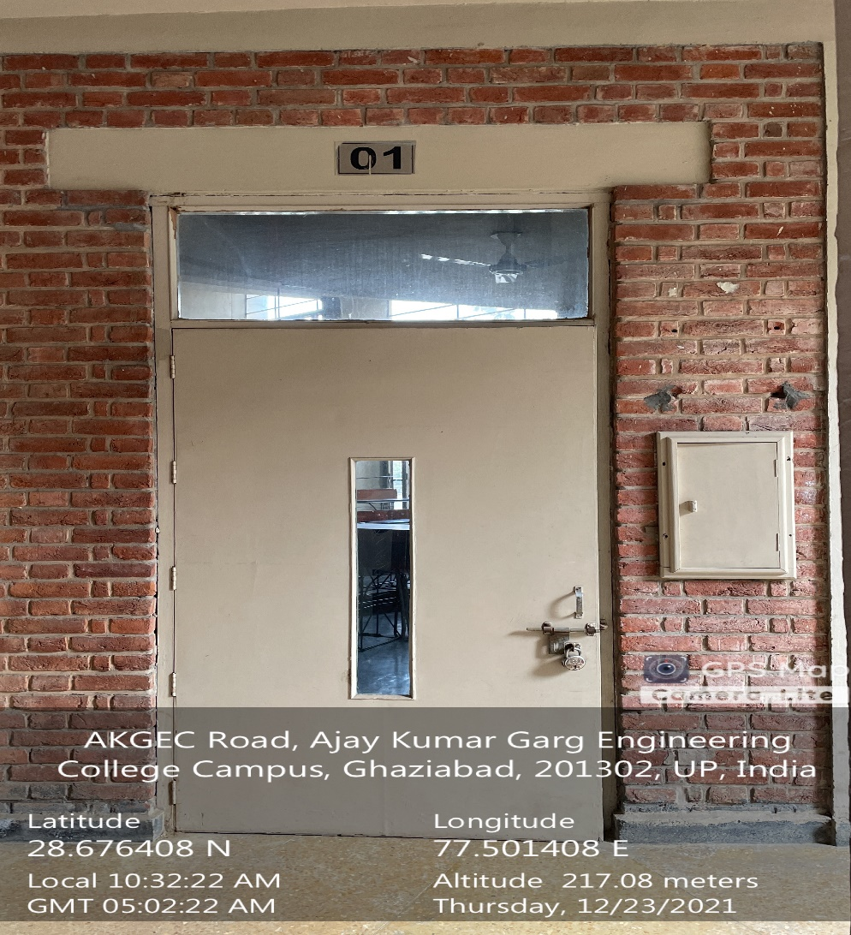

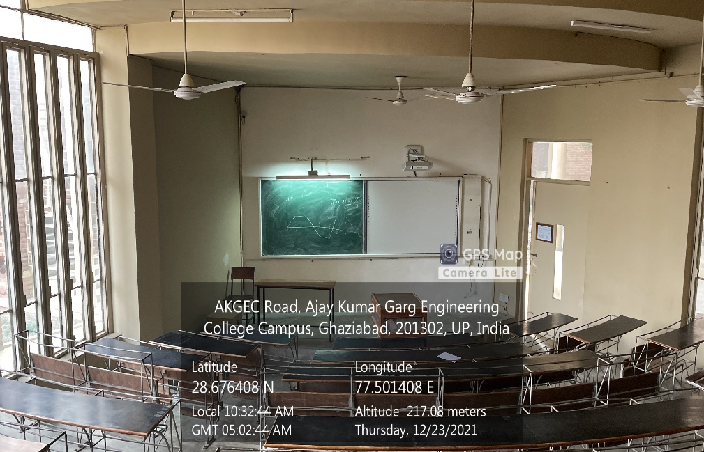

**LT Complex, Ground Floor, LT01**

**(Available Facilities: Green Board, Smart Board, Wi-Fi, Sound system)**

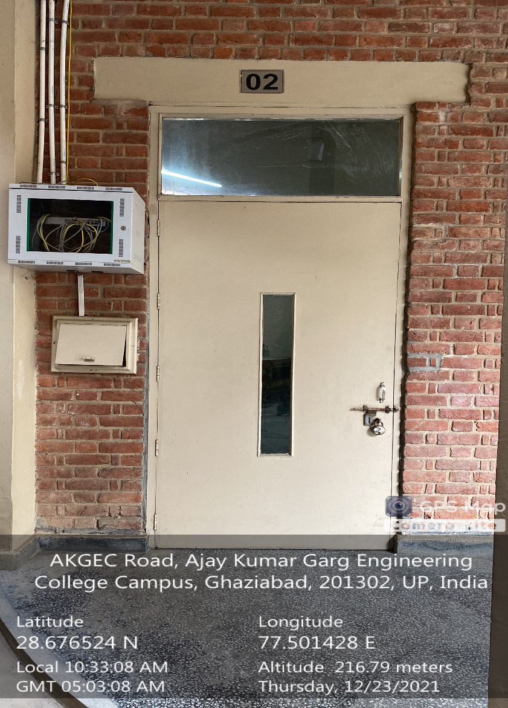

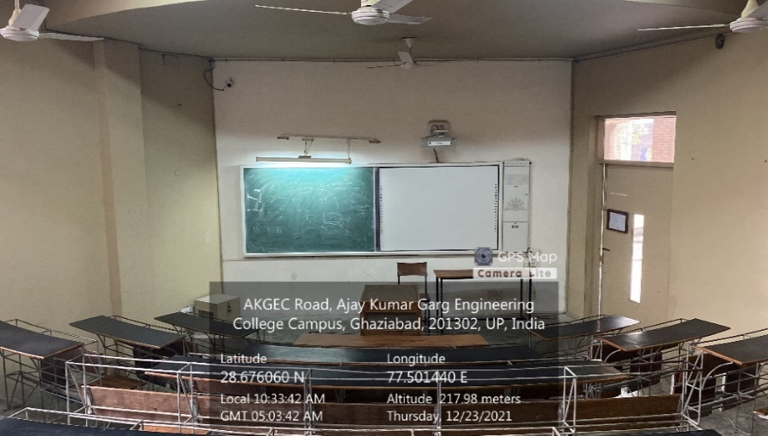

**LT Complex, Ground Floor, LT02**

**(Available Facilities: Green Board, Smart Board, Wi-Fi, Sound system)**

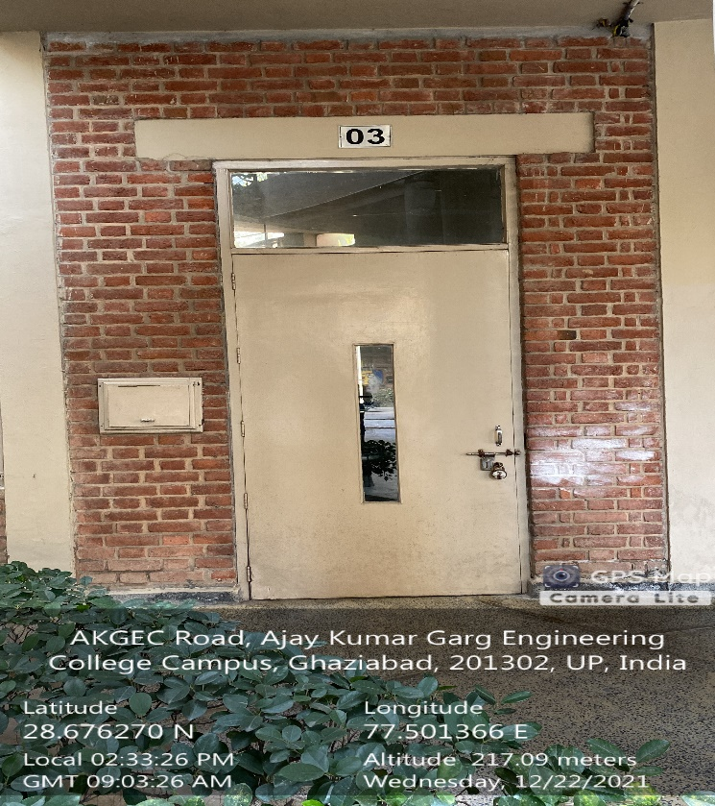

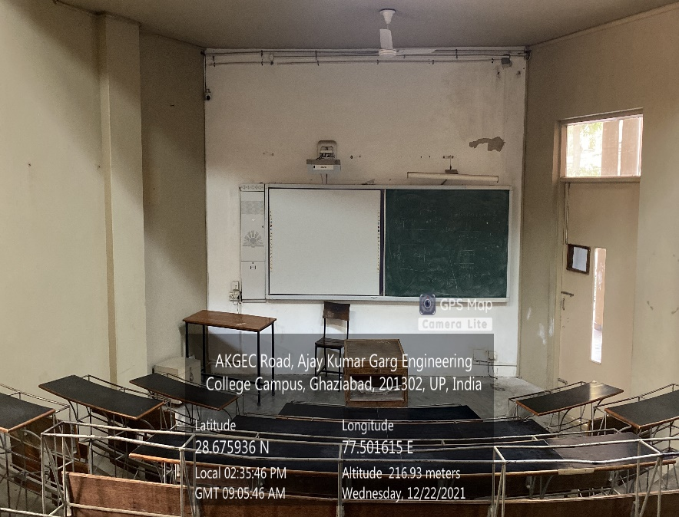

**LT Complex, Ground Floor, LT03**

**(Available Facilities: Green Board, Smart Board, Wi-Fi, Sound system)**

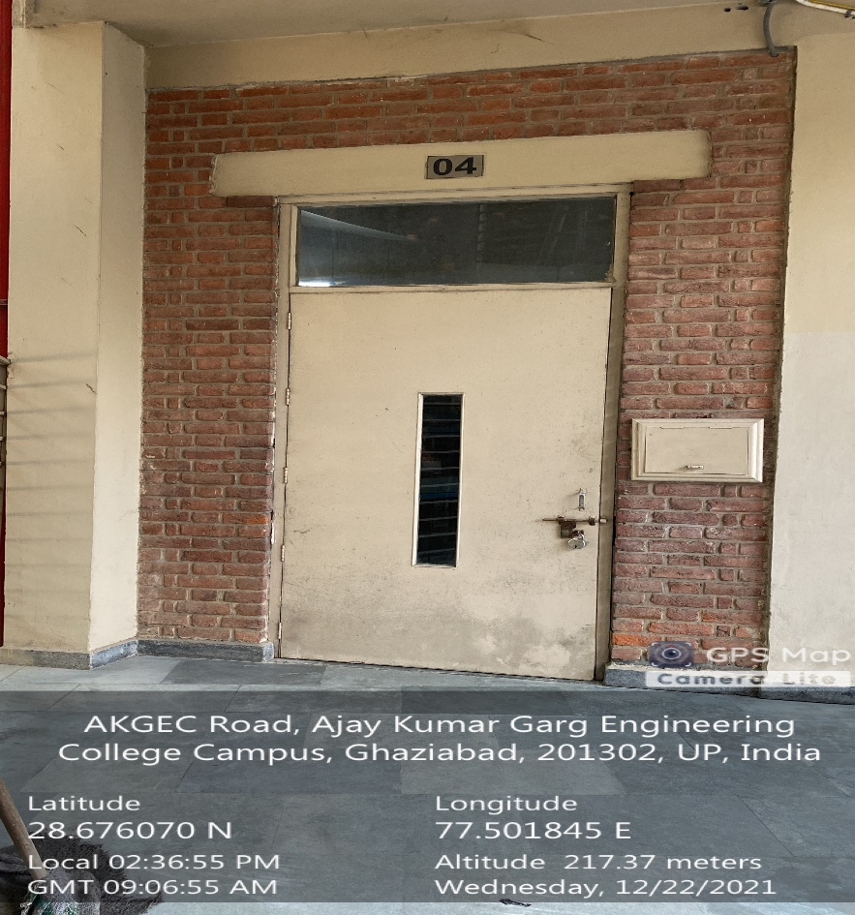

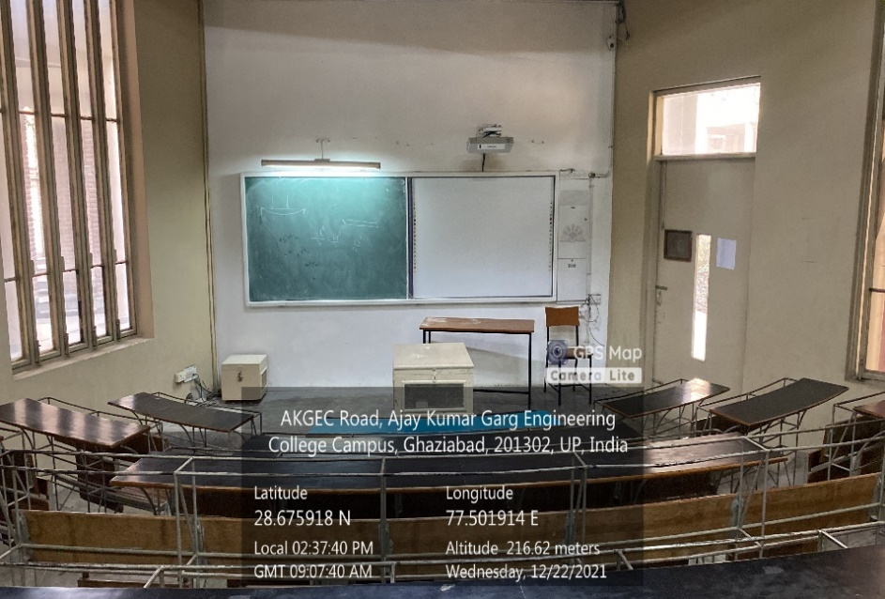

**LT Complex, Ground Floor, LT04**

**(Available Facilities: Green Board, Smart Board, Wi-Fi, Sound system)**

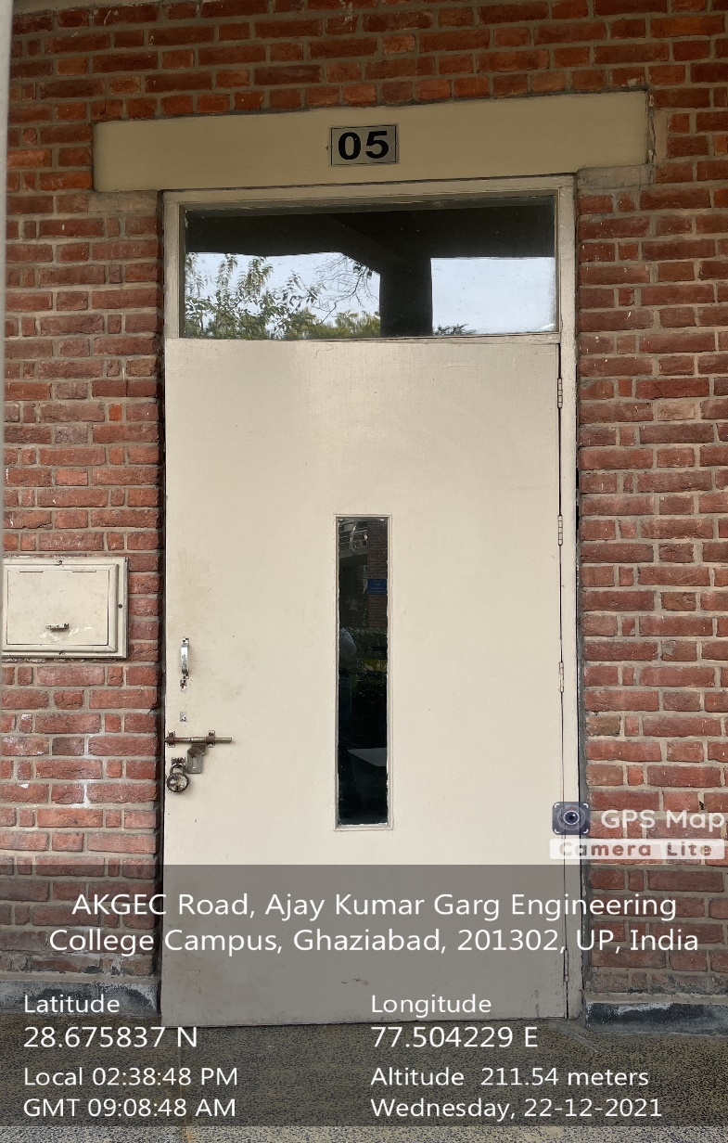

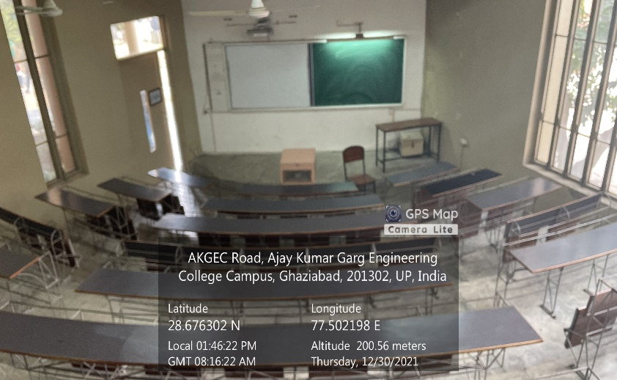

**LT Complex, Ground Floor, LT05**

**(Available Facilities: Green Board, Smart Board, Wi-Fi, Sound system)**

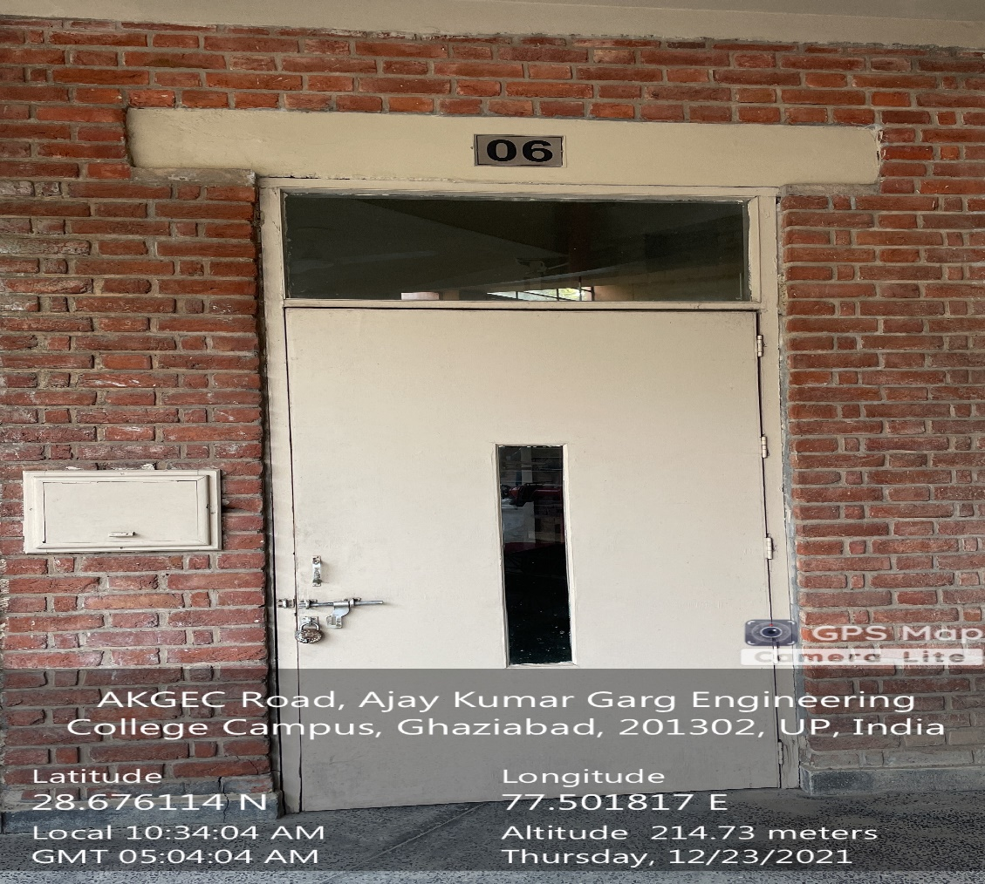

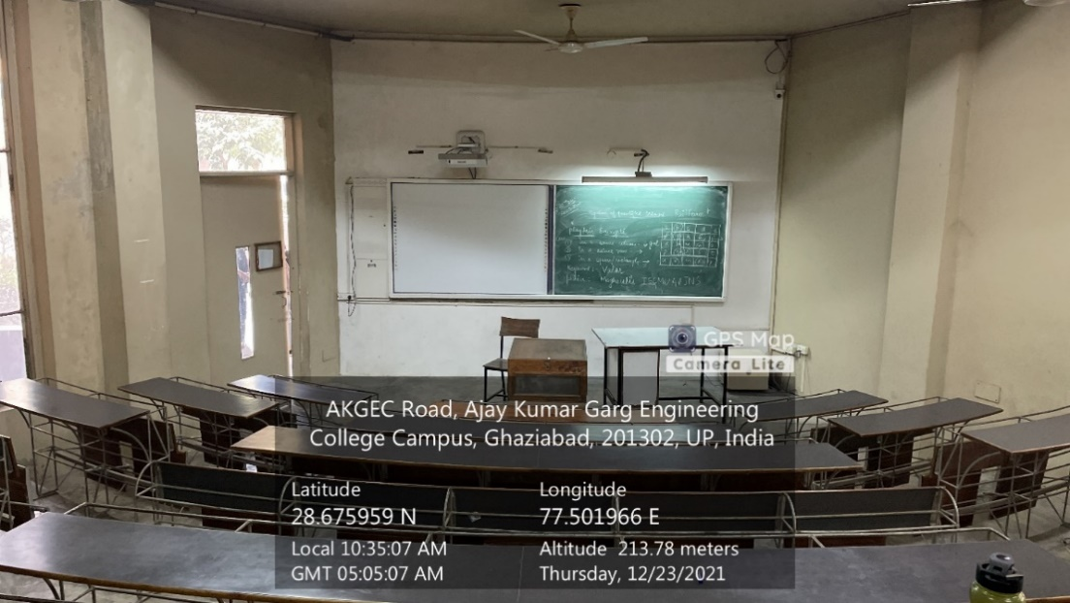

**LT Complex, Ground Floor, LT06**

**(Available Facilities: Green Board, Smart Board, Wi-Fi, Sound system)**

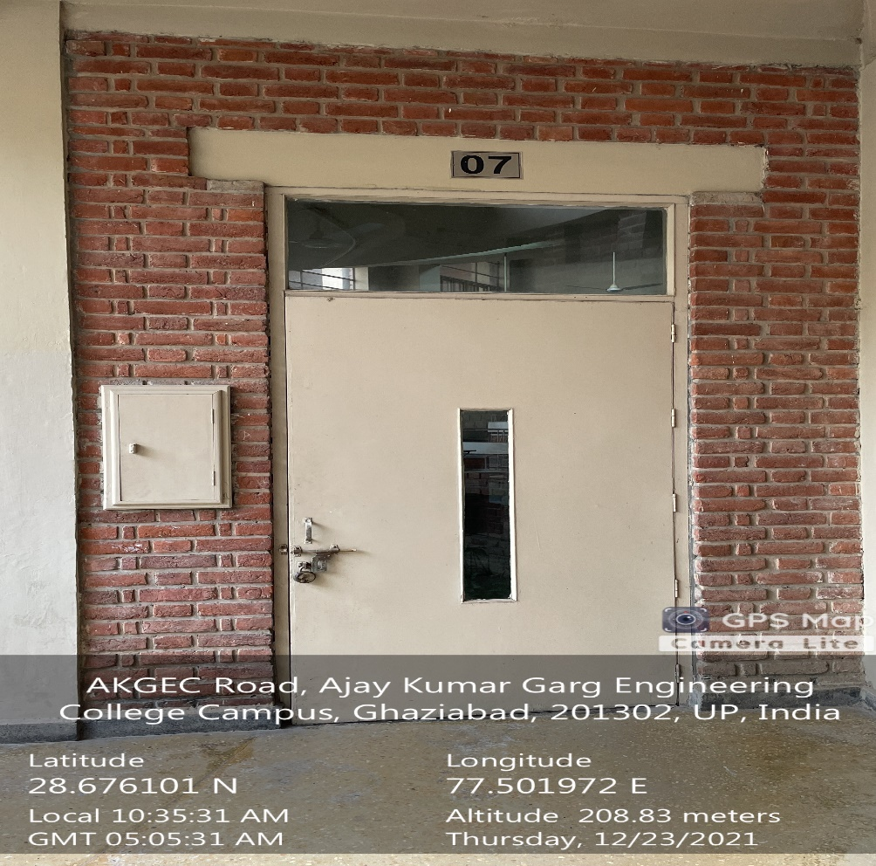

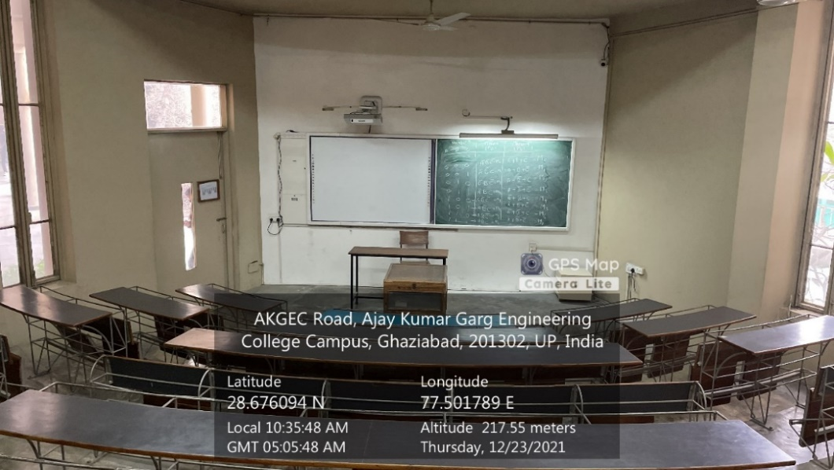

**LT Complex, Ground Floor, LT07**

**(Available Facilities: Green Board, Smart Board, Wi-Fi, Sound system)**

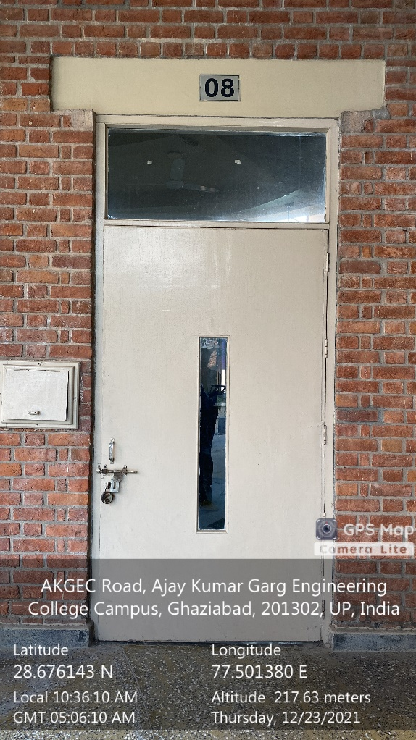

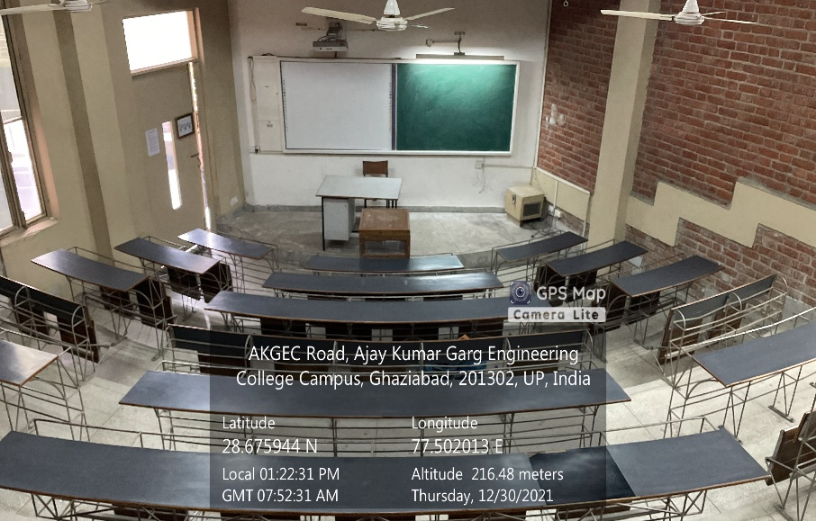

**LT Complex, Ground Floor, LT08**

**(Available Facilities: Green Board, Smart Board, Wi-Fi, Sound system)**

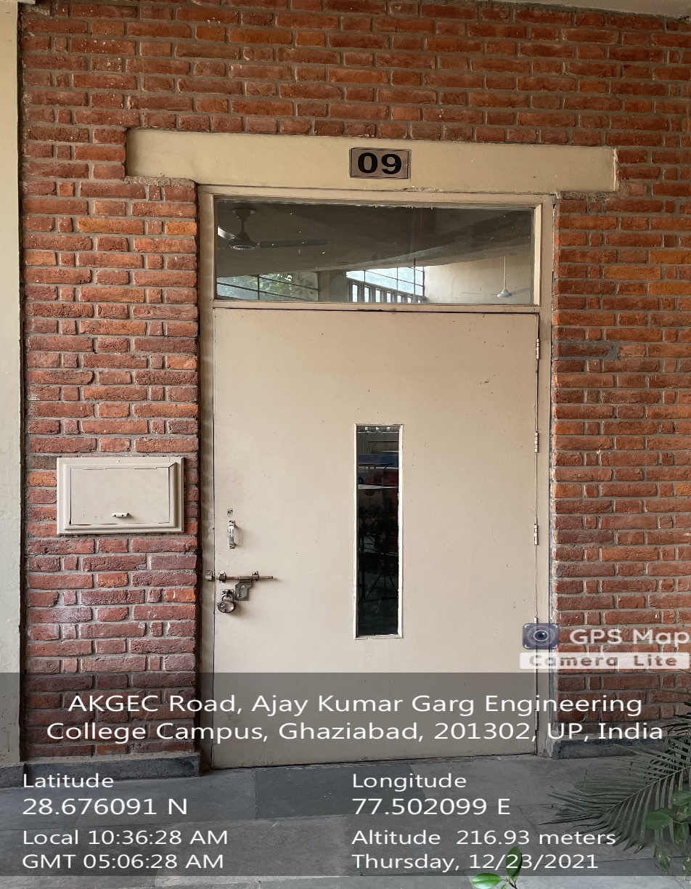

**`** 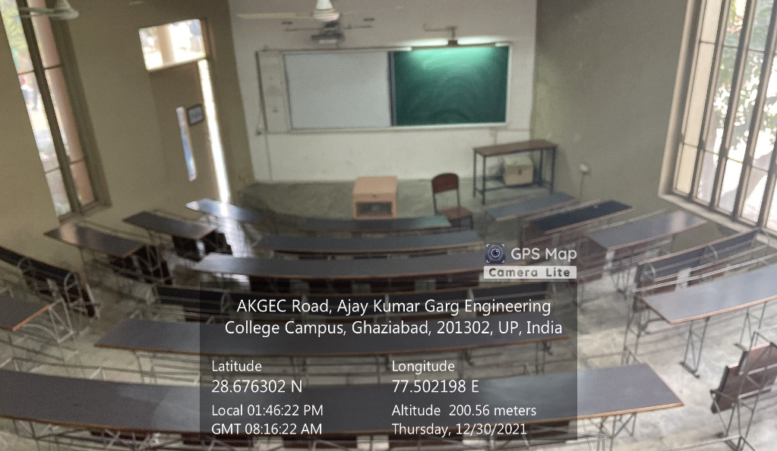

**LT Complex, Ground Floor, LT09**

**(Available Facilities: Green Board, Smart Board, Wi-Fi, Sound system)**

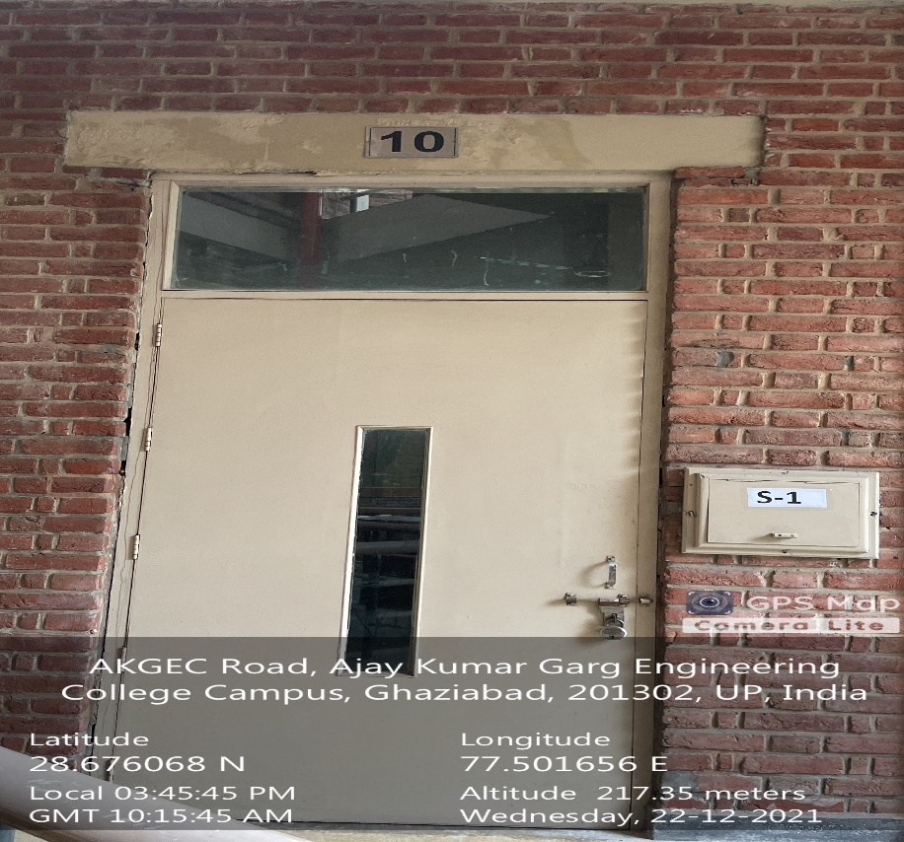

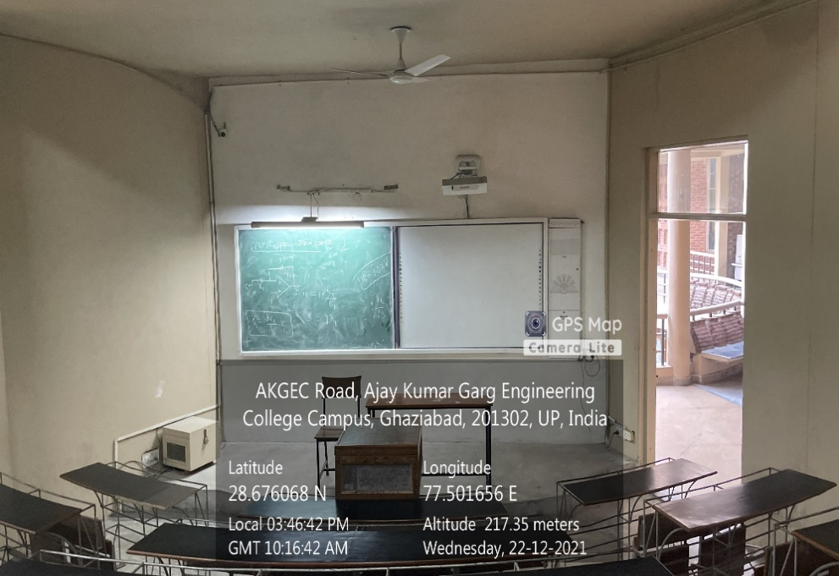

**LT Complex, First Floor, LT10**

**(Available Facilities: Green Board, Smart Board, Wi-Fi, Sound system)**

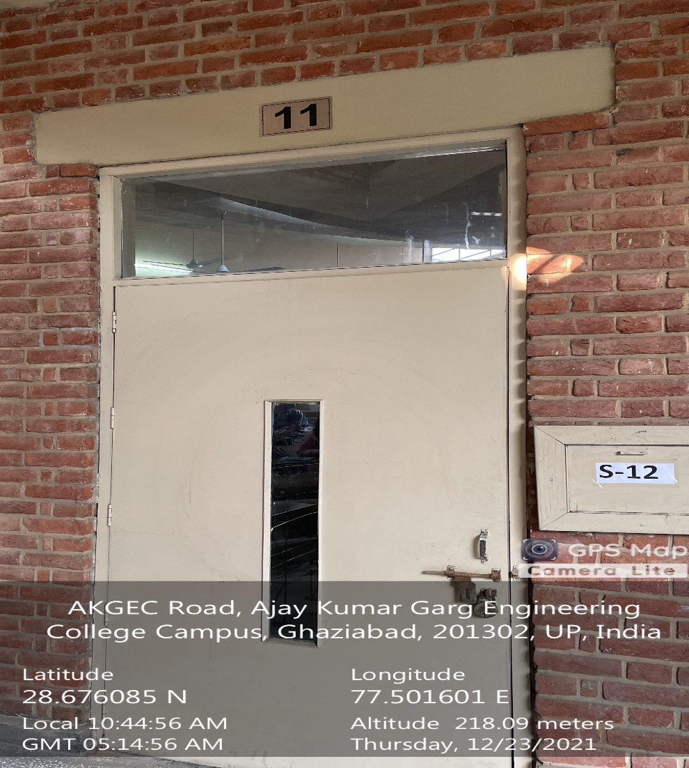

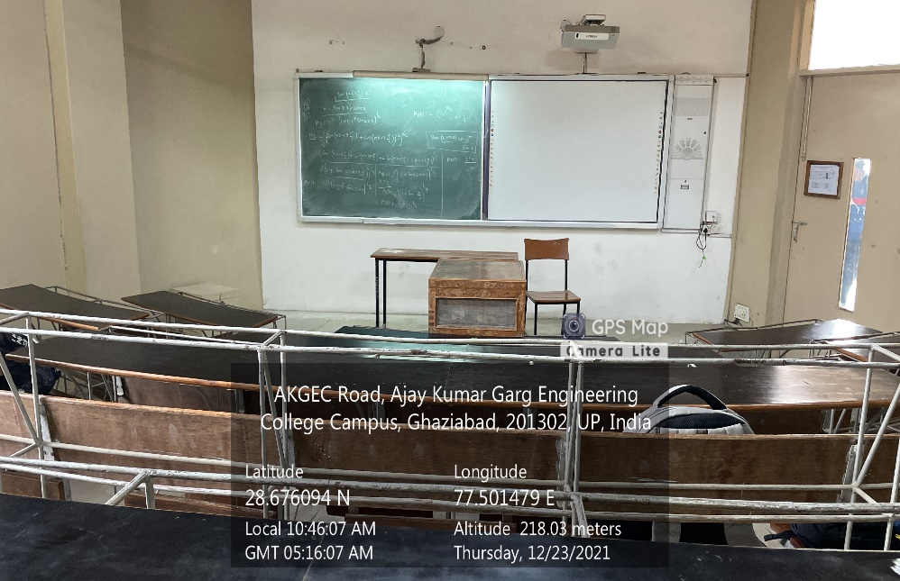

**LT Complex, First Floor, LT11**

**(Available Facilities: Green Board, Smart Board, Wi-Fi, Sound system)**

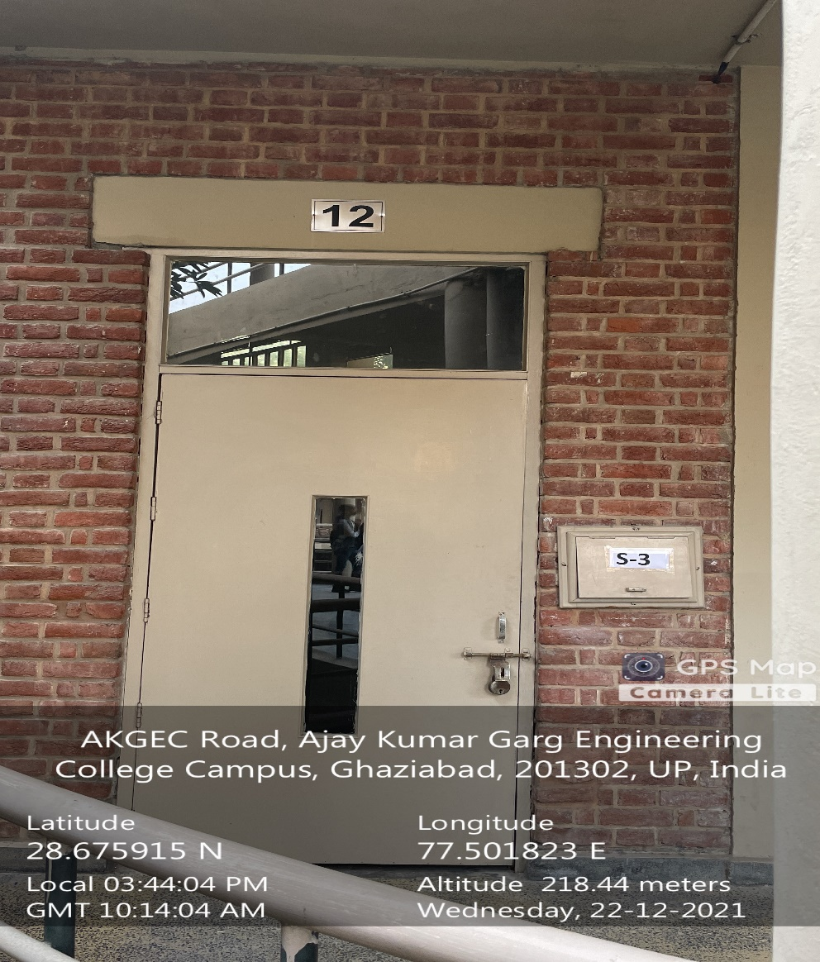

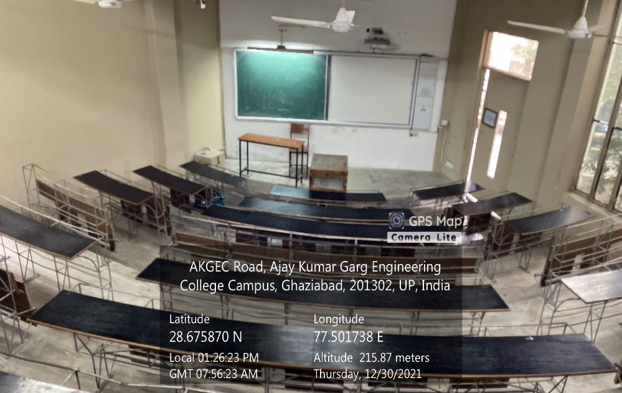

**LT Complex, First Floor, LT12**

**(Available Facilities: Green Board, Smart Board, Wi-Fi, Sound system)**

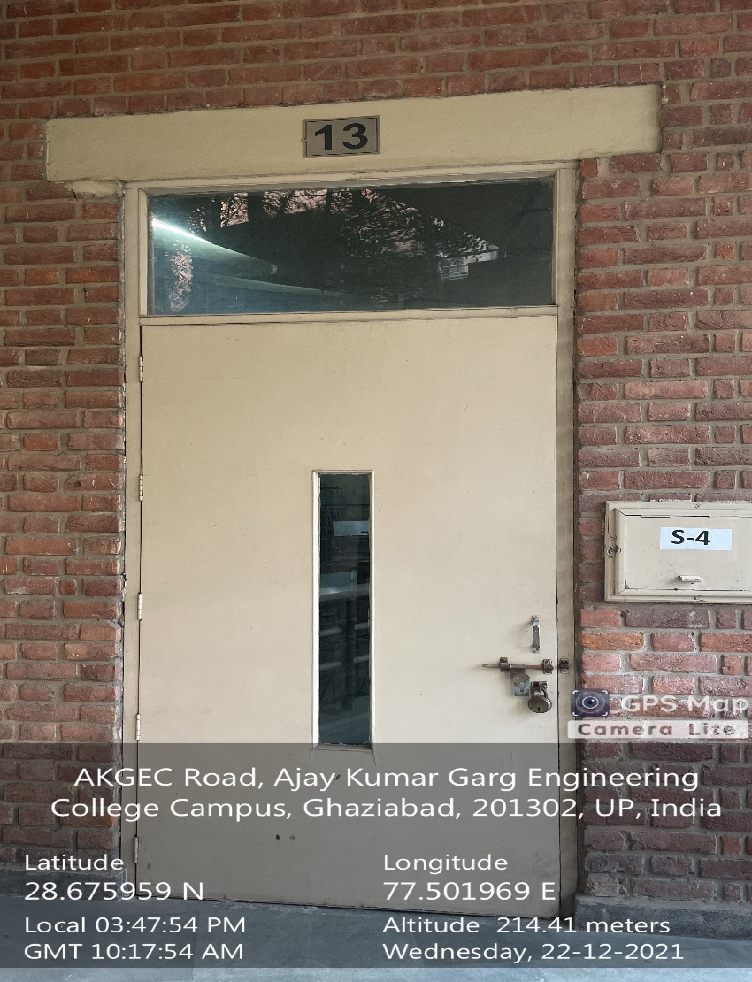

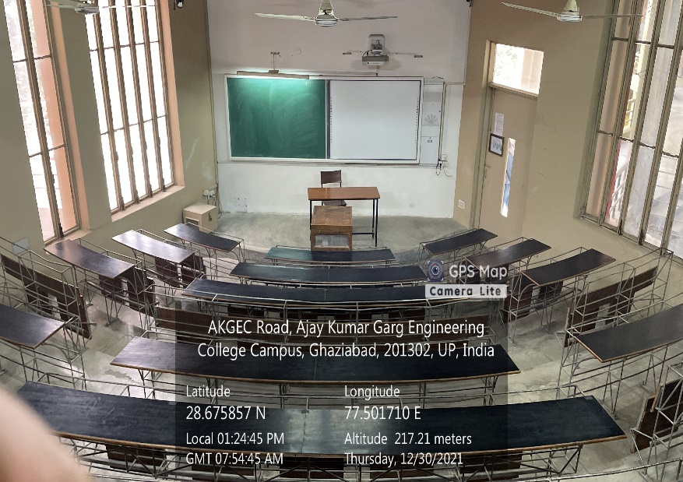

**LT Complex, First Floor, LT13**

**(Available Facilities: Green Board, Smart Board, Wi-Fi, Sound system)**

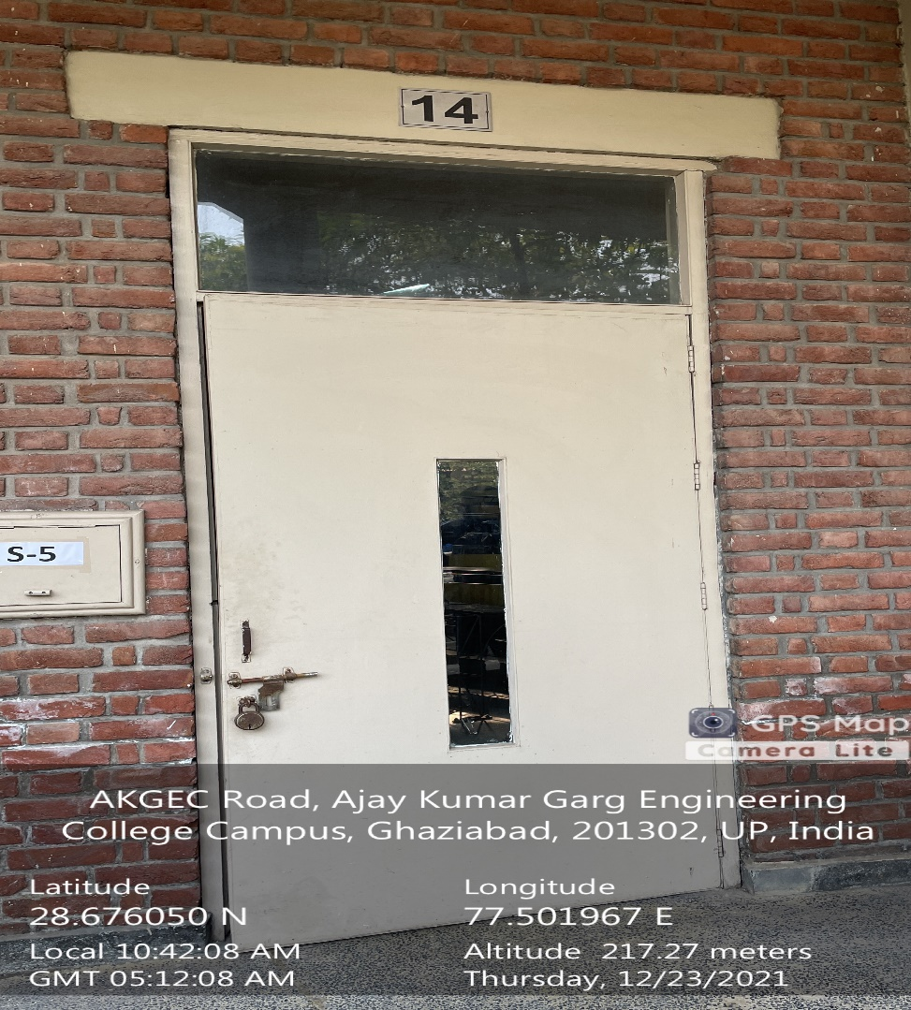

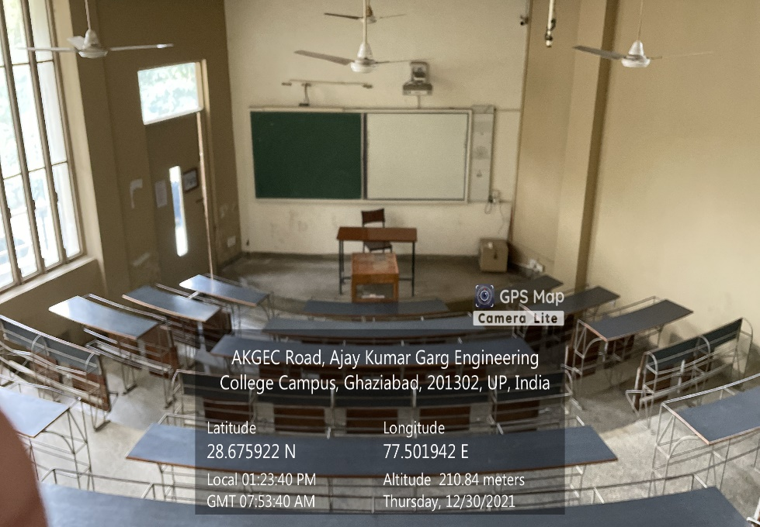

**LT Complex, First Floor, LT14**

**(Available Facilities: Green Board, Smart Board, Wi-Fi, Sound system)**

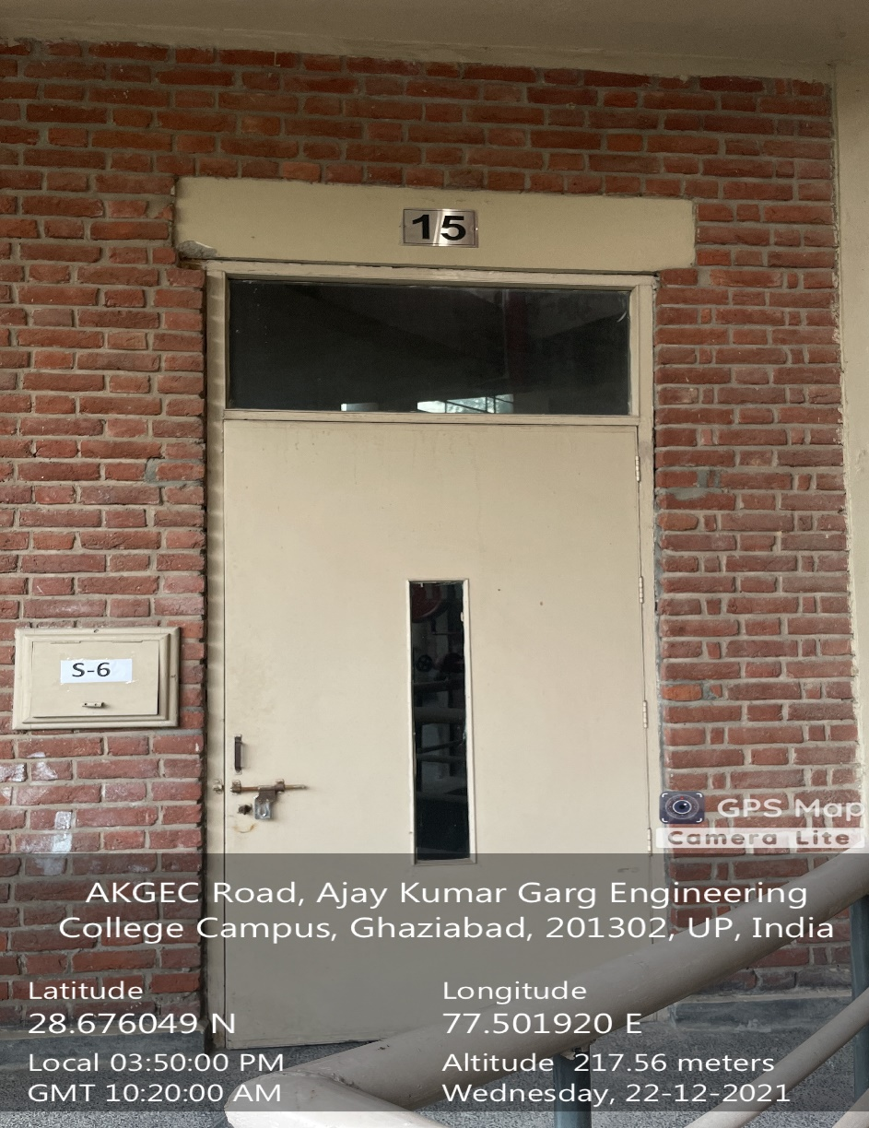

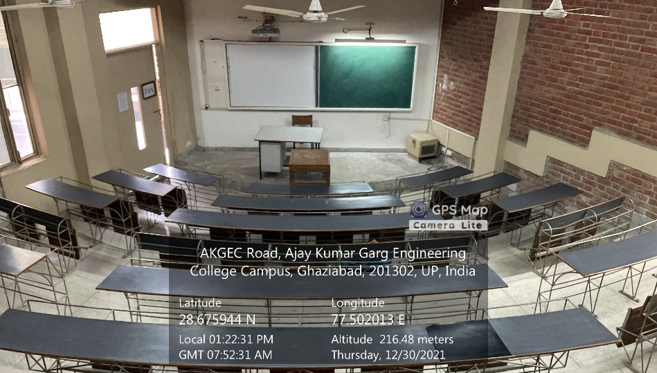

**LT Complex, First Floor, LT15**

**(Available Facilities: Green Board, Smart Board, Wi-Fi, Sound system)**

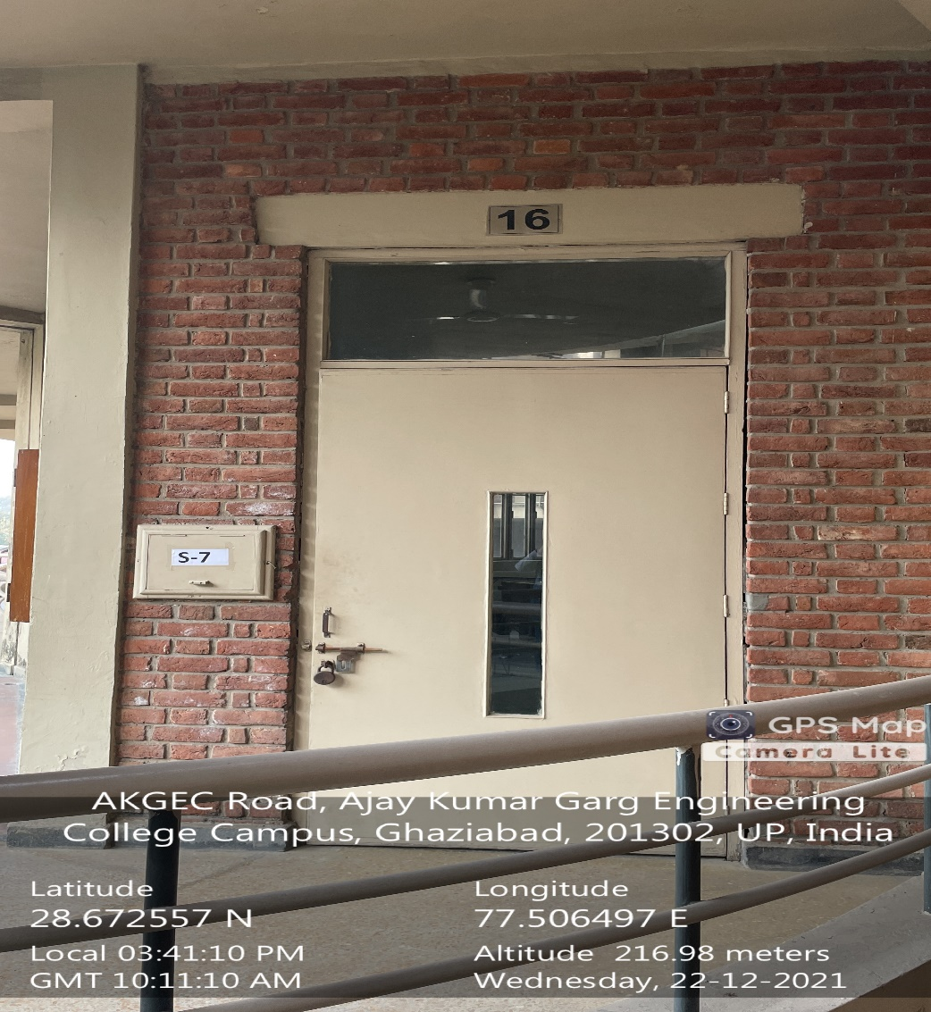

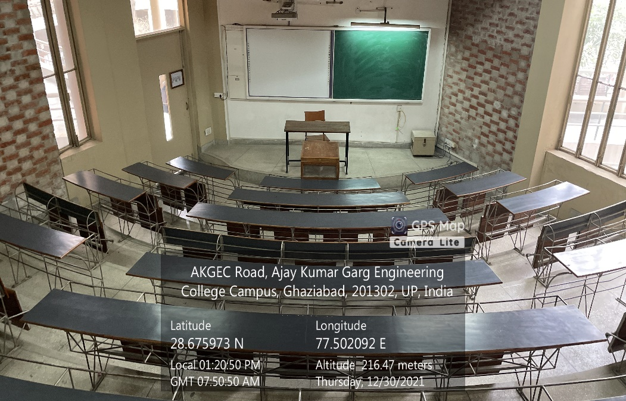

**LT Complex, First Floor, LT16**

**(Available Facilities: Green Board, Smart Board, Wi-Fi, Sound system)**

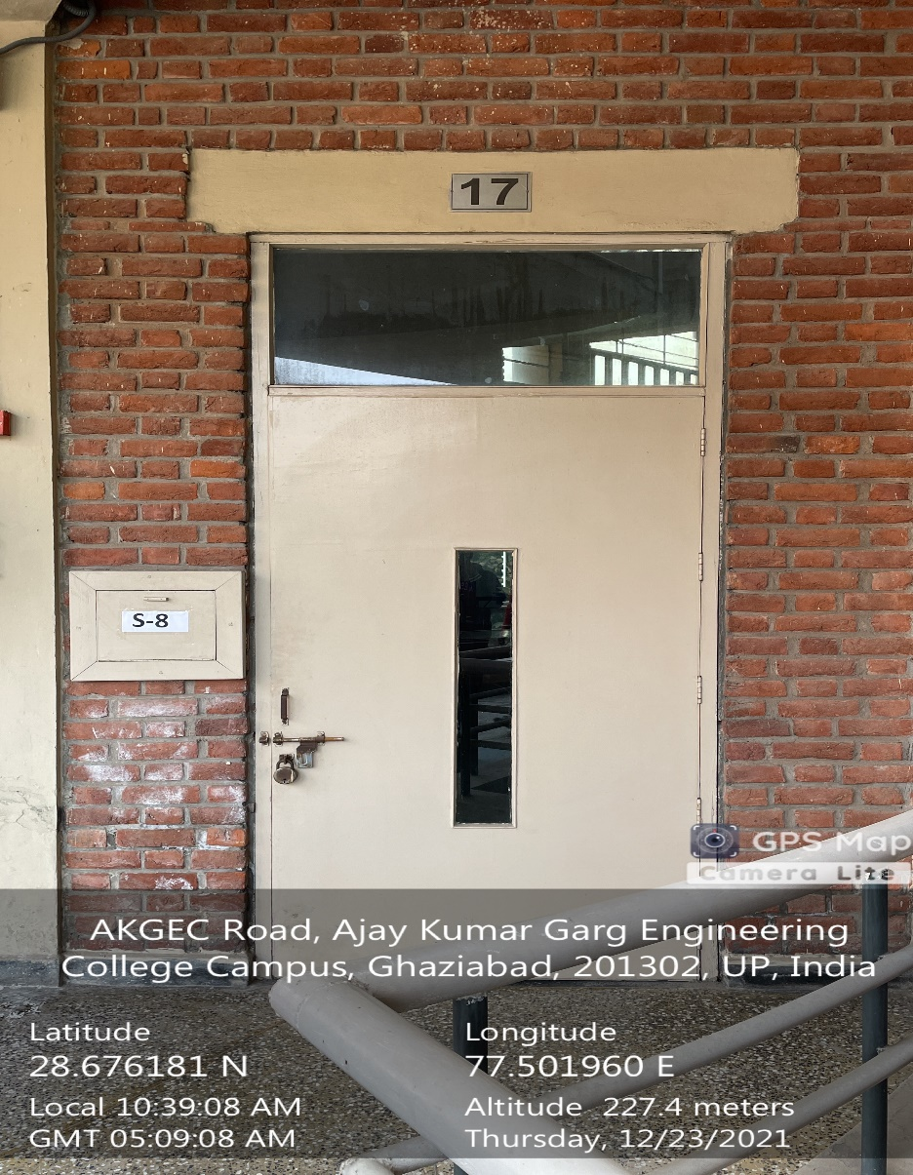

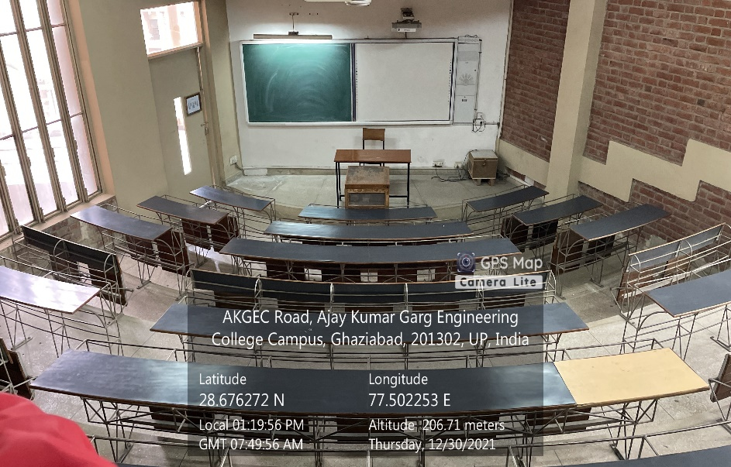

**LT Complex, First Floor, LT17**

**(Available Facilities: Green Board, Smart Board, Wi-Fi, Sound system)**

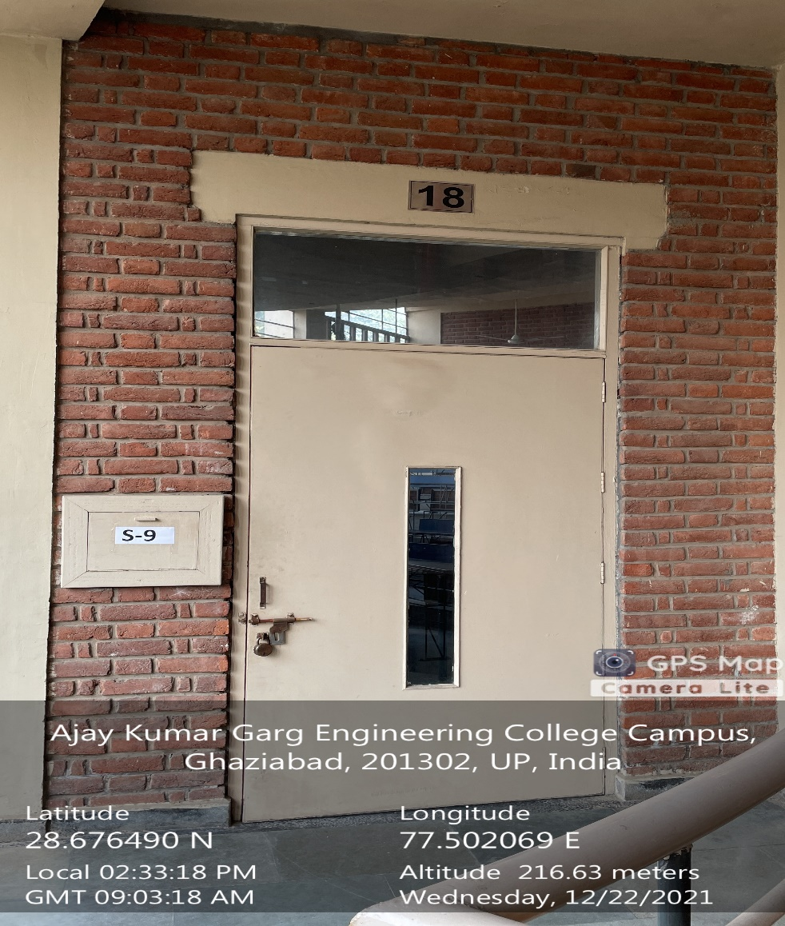

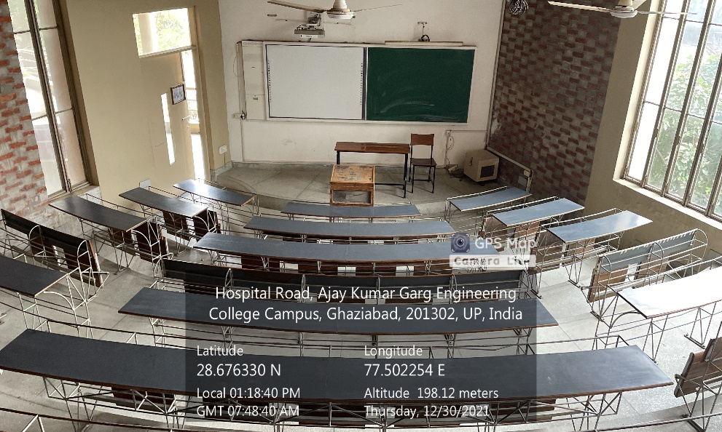

**LT Complex, First Floor, LT18**

**(Available Facilities: Green Board, Smart Board, Wi-Fi, Sound system)**

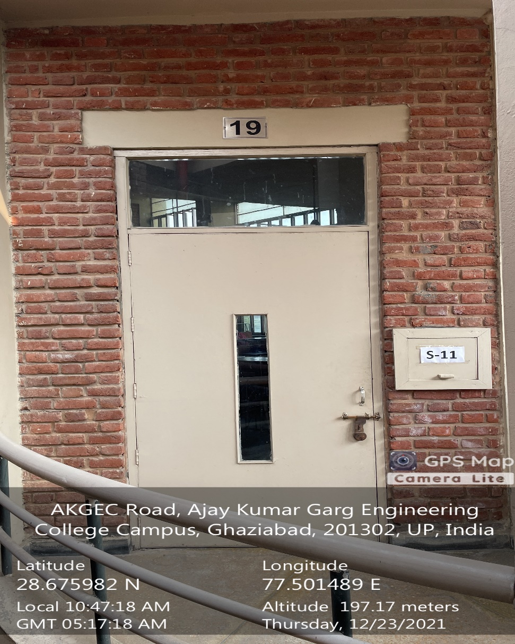

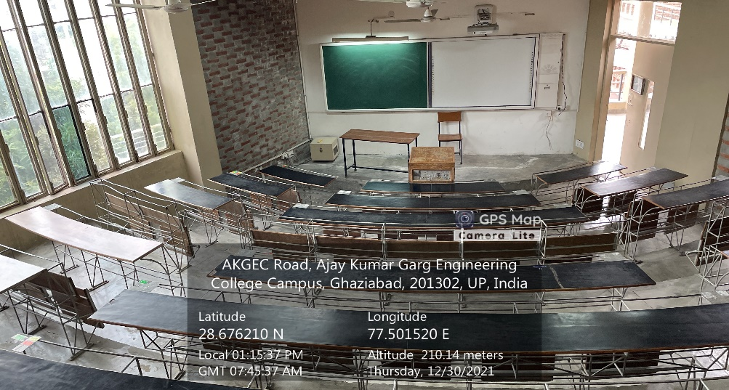

**LT Complex, Second Floor, LT19**

**(Available Facilities: Green Board, Smart Board, Wi-Fi, Sound system)**

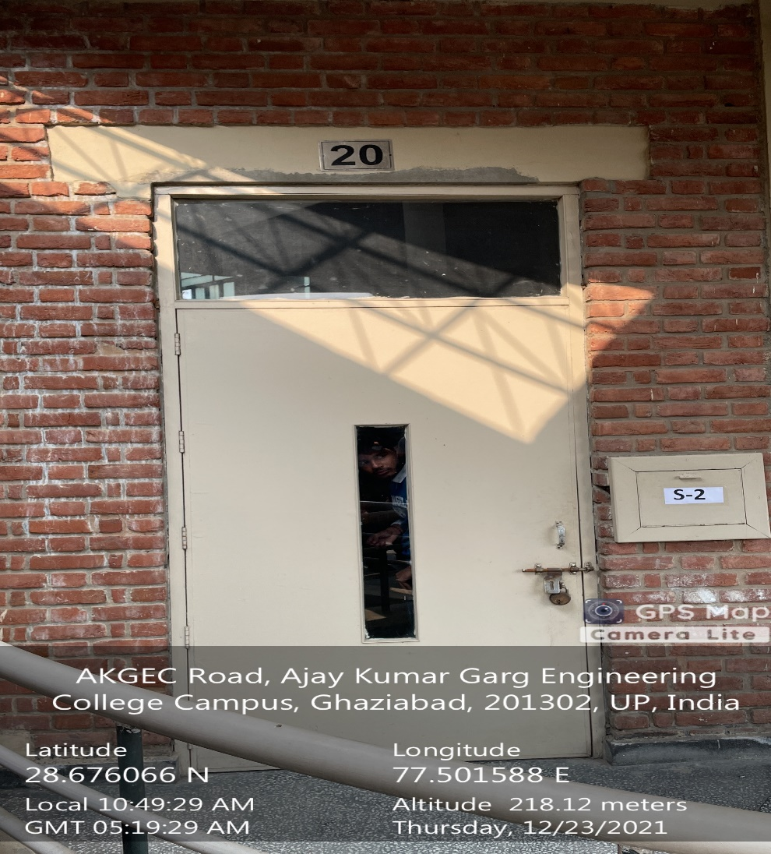

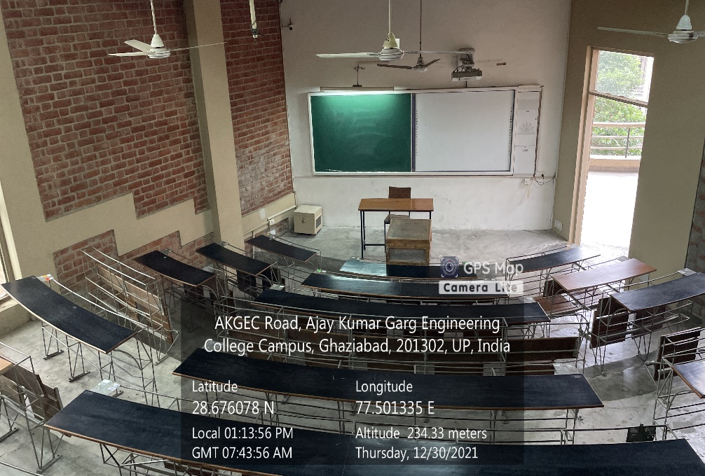

**LT Complex, Second Floor, LT20**

**(Available Facilities: Green Board, Smart Board, Wi-Fi, Sound system)**

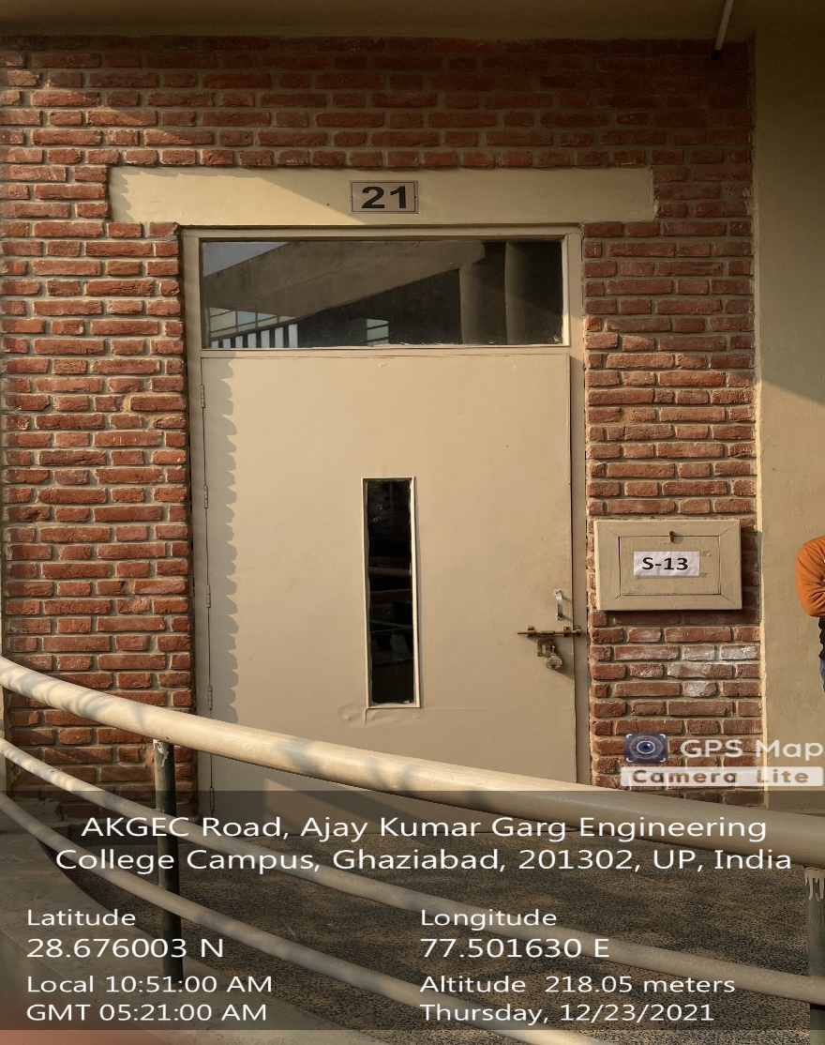

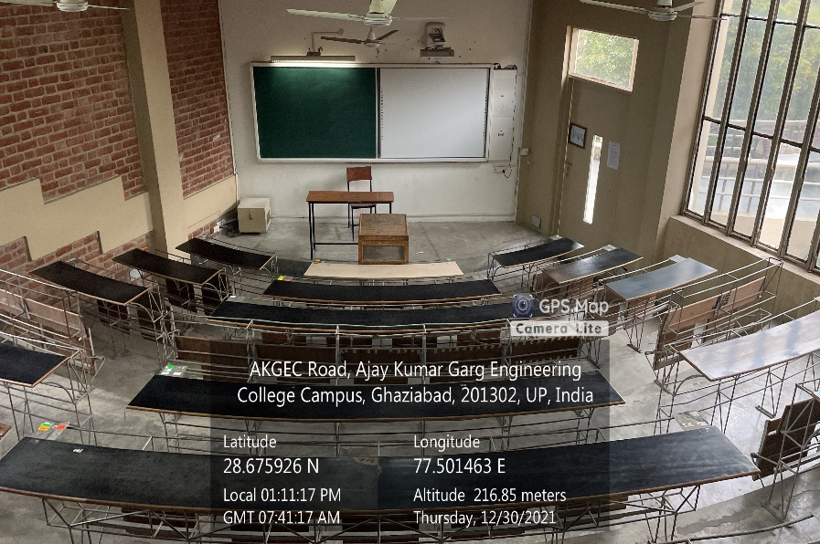

**LT Complex, Second Floor, LT21**

**(Available Facilities: Green Board, Smart Board, Wi-Fi, Sound system)**

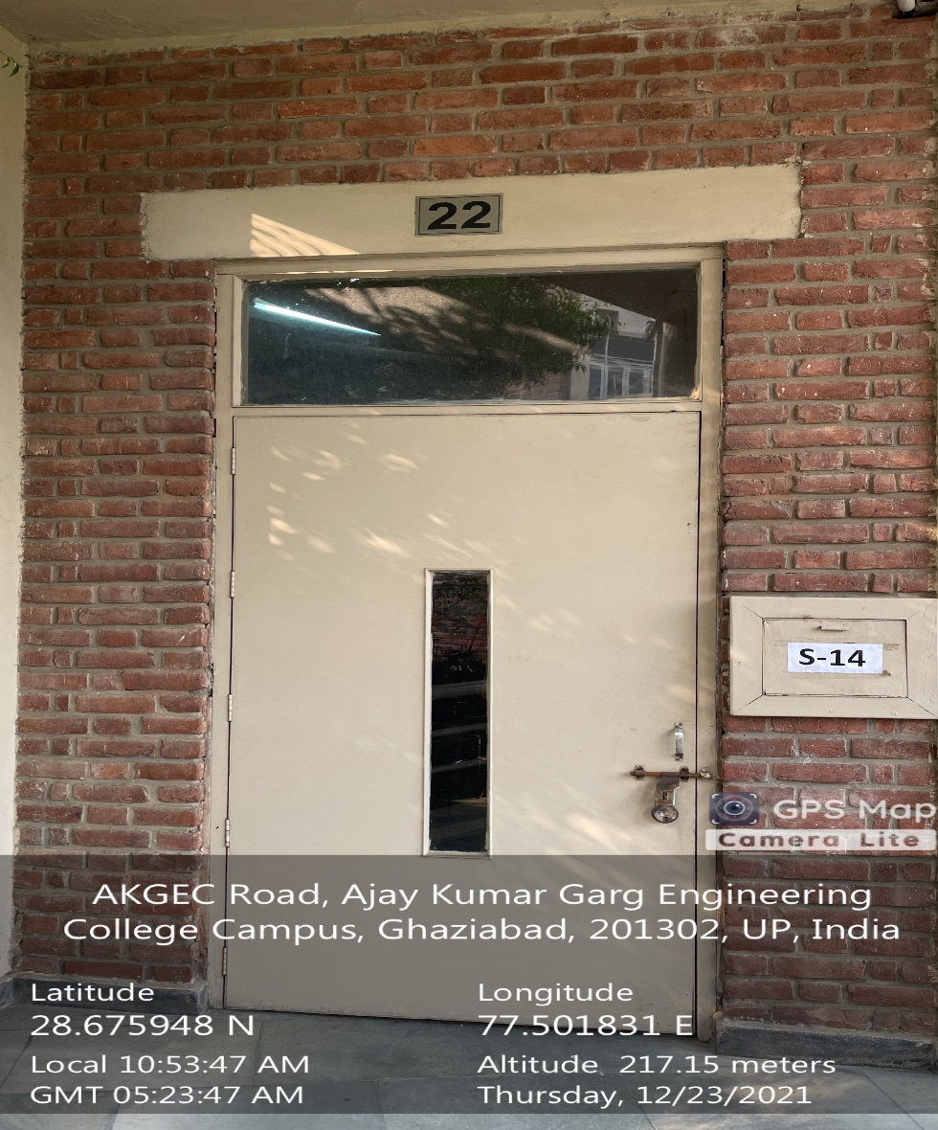

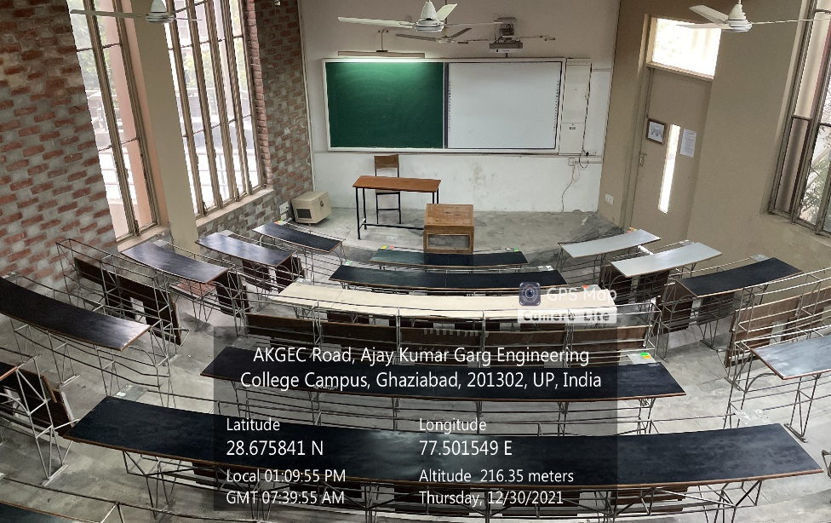

**LT Complex, Second Floor, LT22**

**(Available Facilities: Green Board, Smart Board, Wi-Fi, Sound system)**

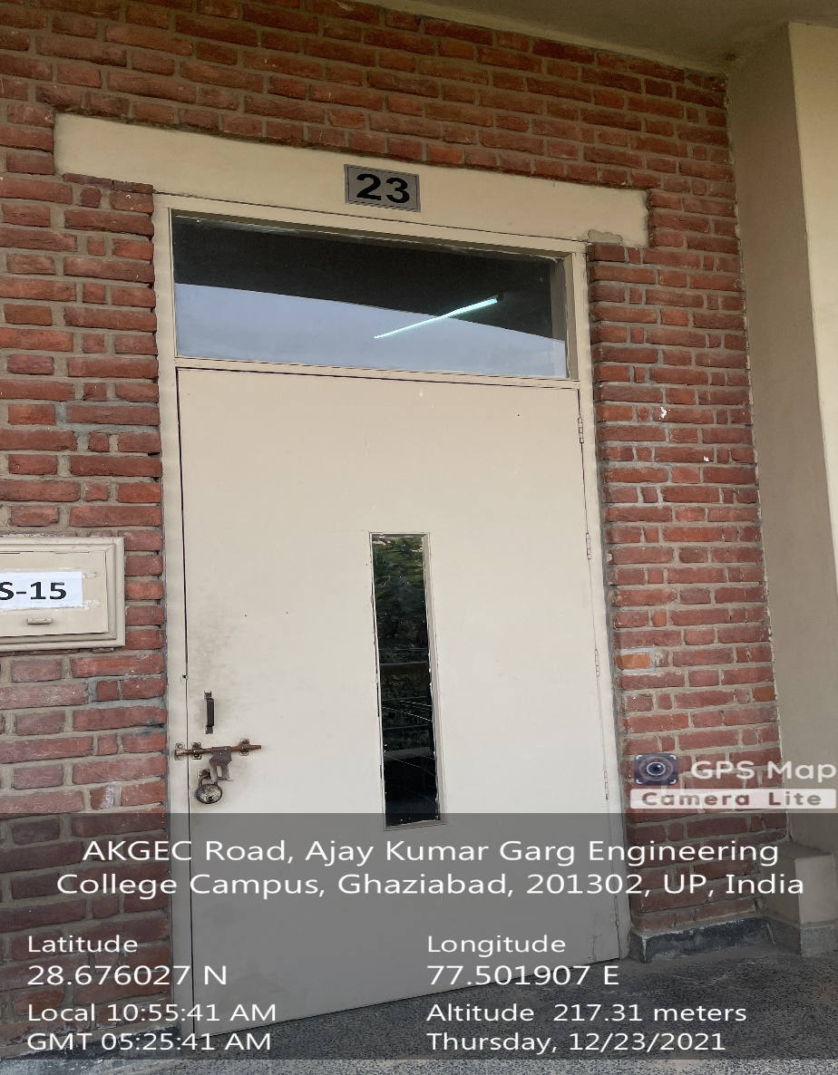

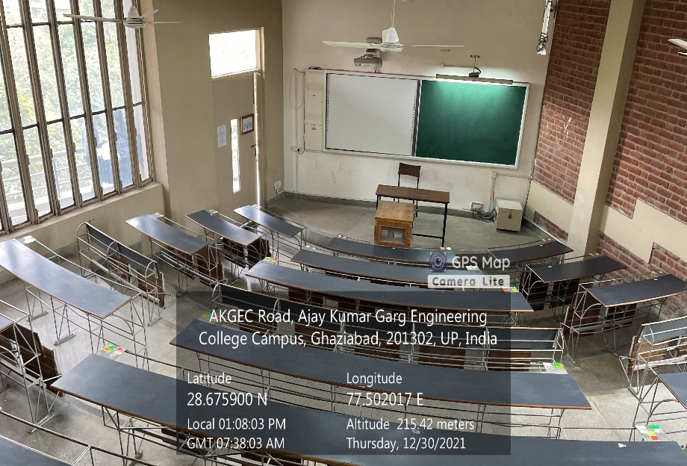

**LT Complex, Second Floor, LT23**

**(Available Facilities: Green Board, Smart Board, Wi-Fi, Sound system)**

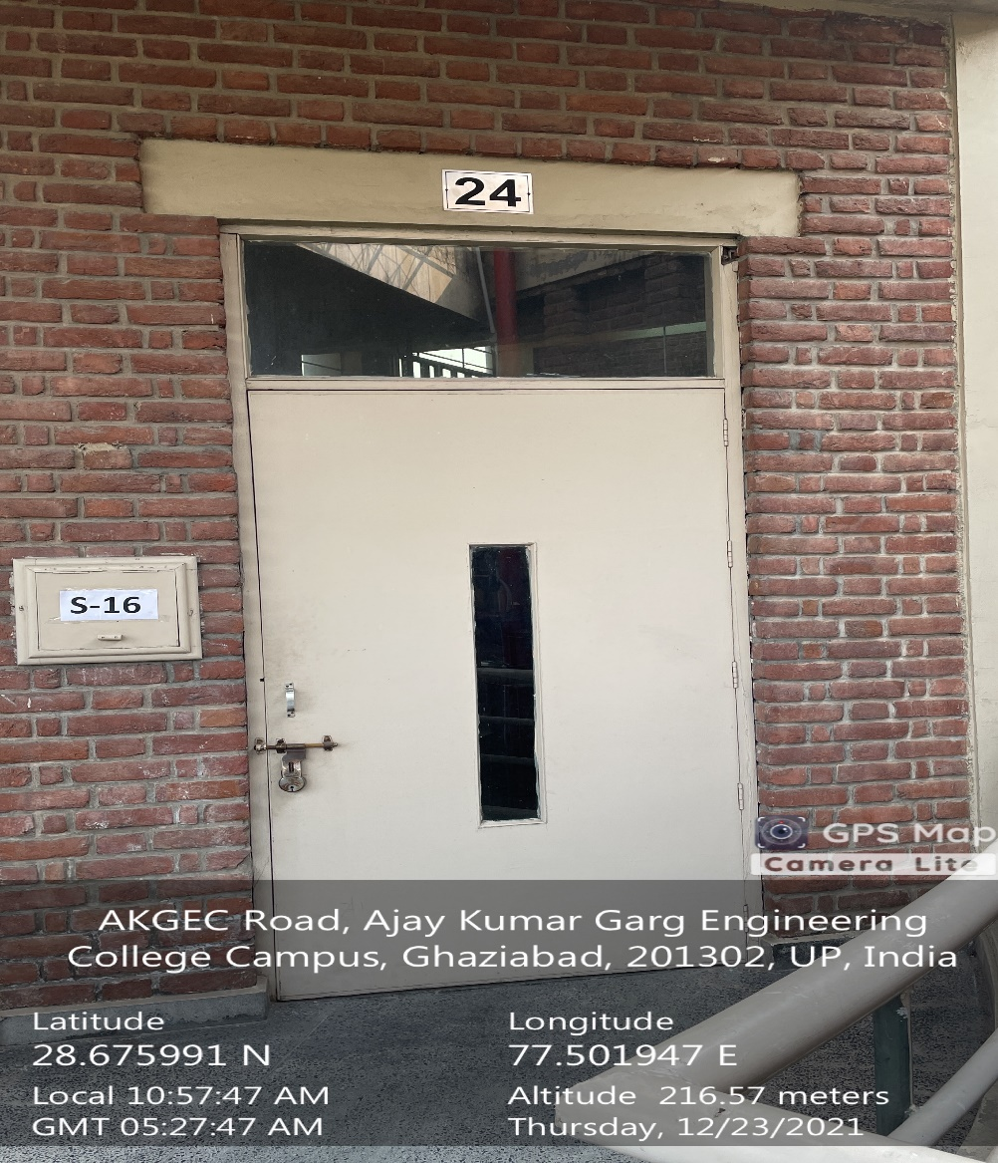

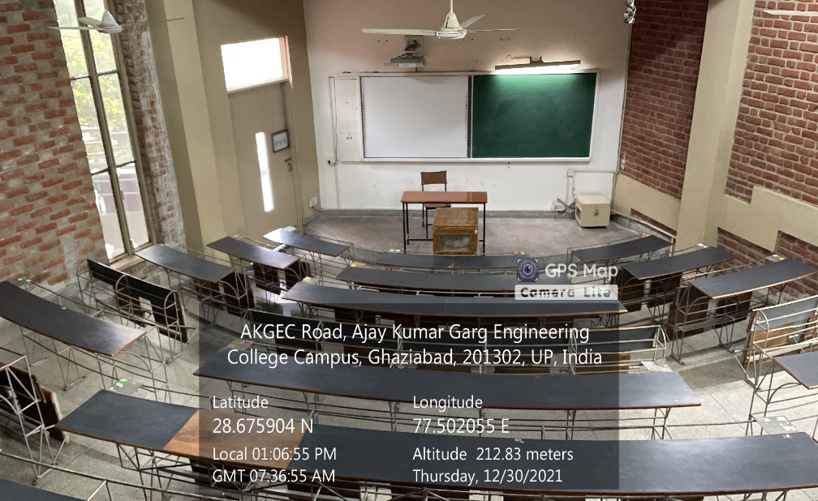

**LT Complex, Second Floor, LT24**

**(Available Facilities: Green Board, Smart Board, Wi-Fi, Sound system)**

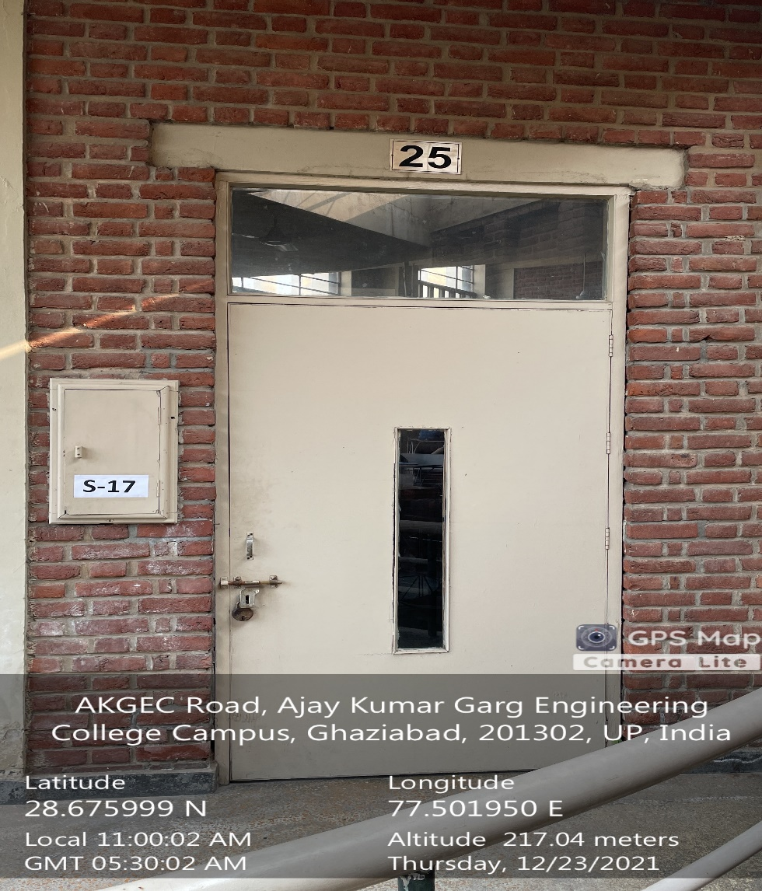

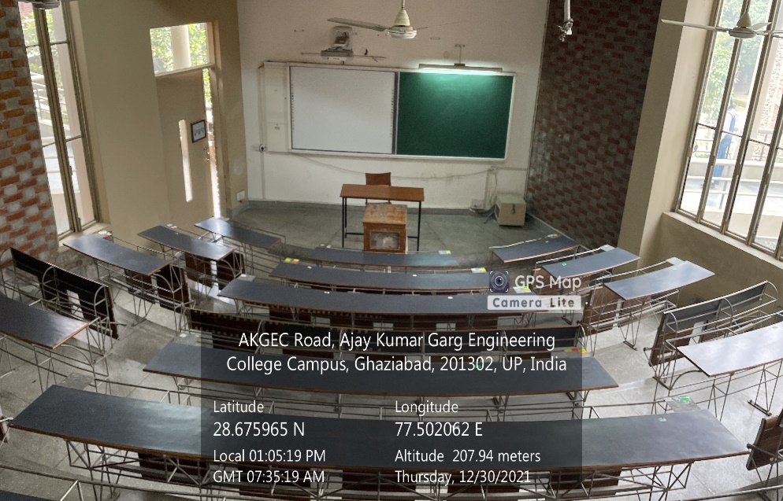

**LT Complex, Second Floor, LT25**

**(Available Facilities: Green Board, Smart Board, Wi-Fi, Sound system)**

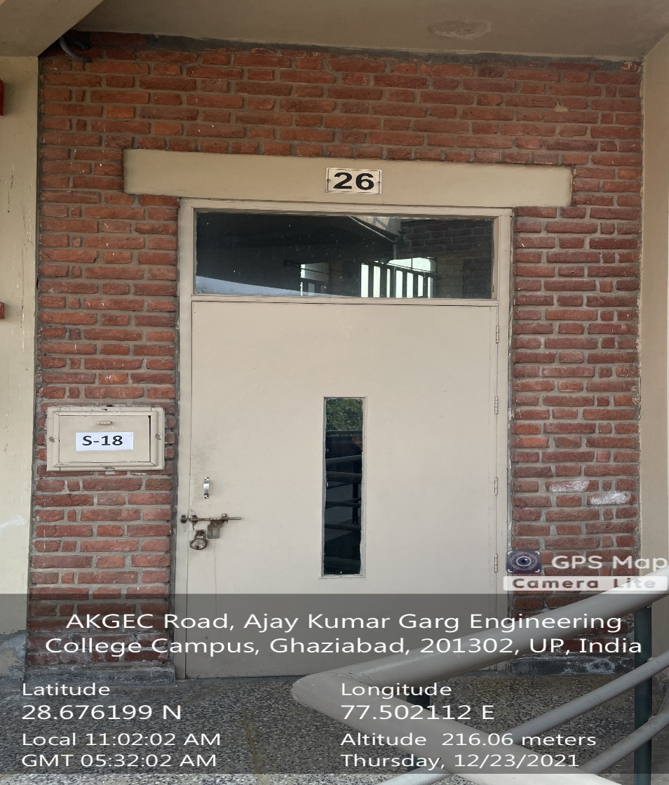

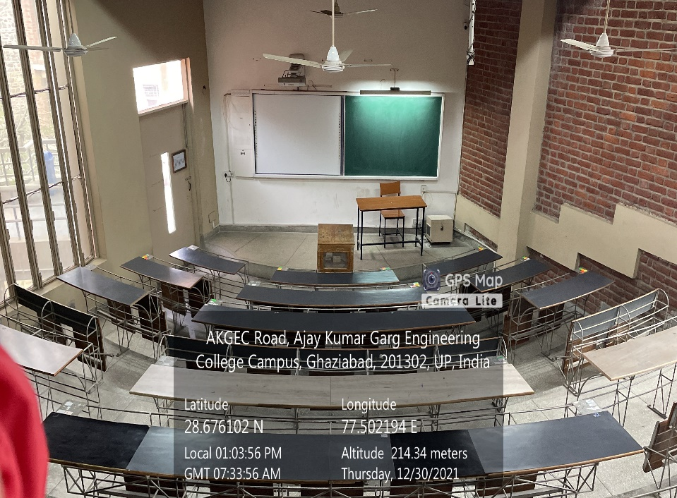

**LT Complex, Second Floor, LT26**

**(Available Facilities: Green Board, Smart Board, Wi-Fi, Sound system)**

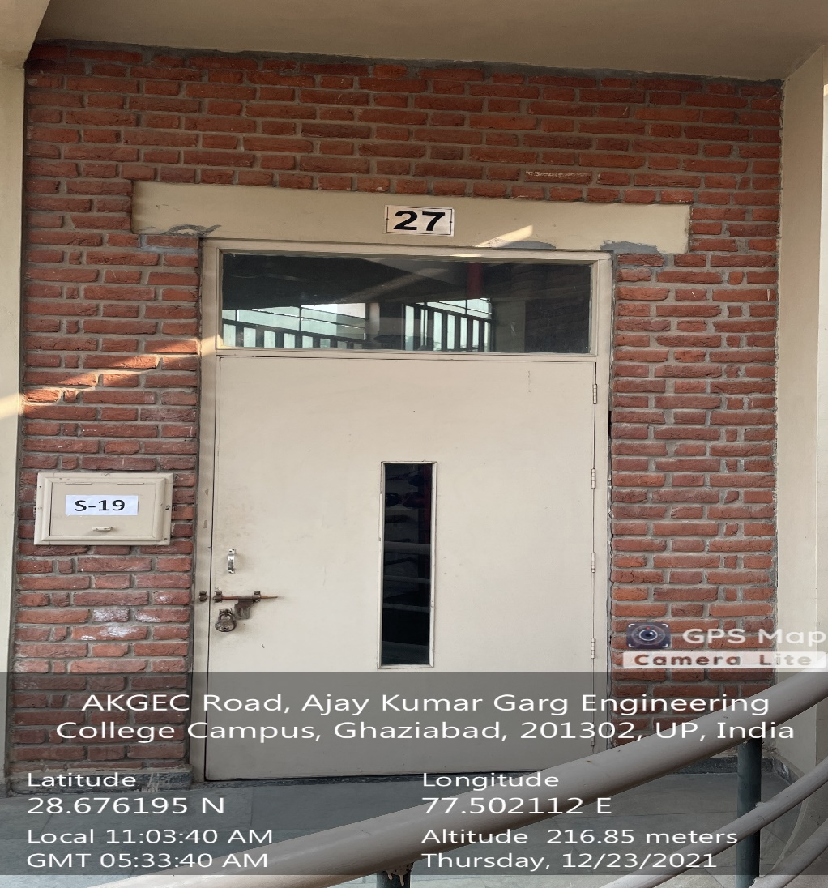

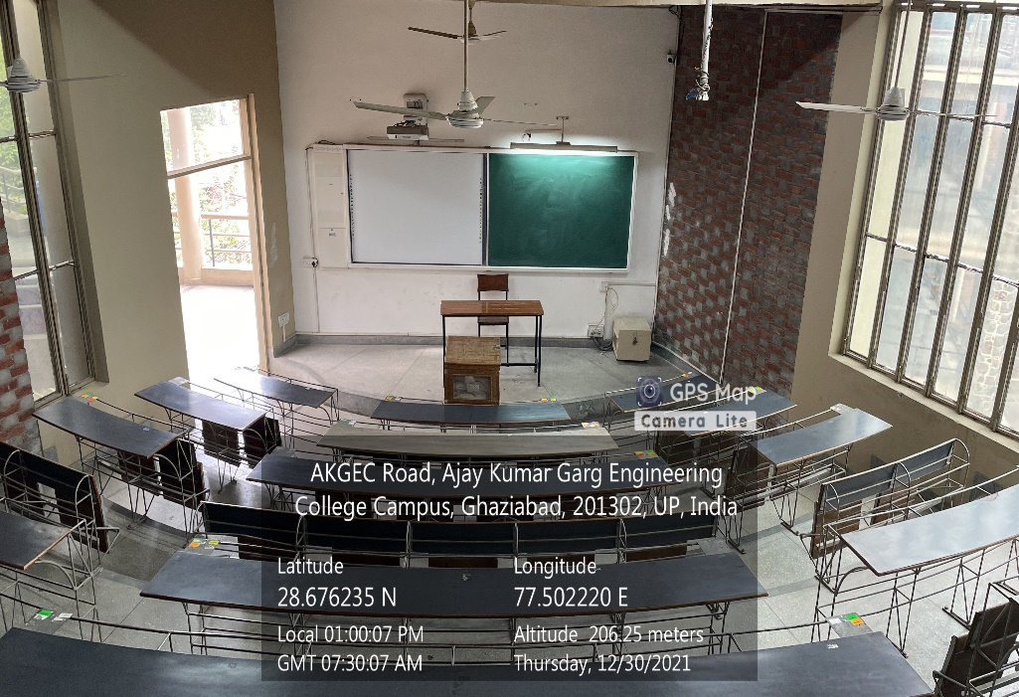

**LT Complex, Second Floor, LT27**

**(Available Facilities: Green Board, Smart Board, Wi-Fi, Sound system)**